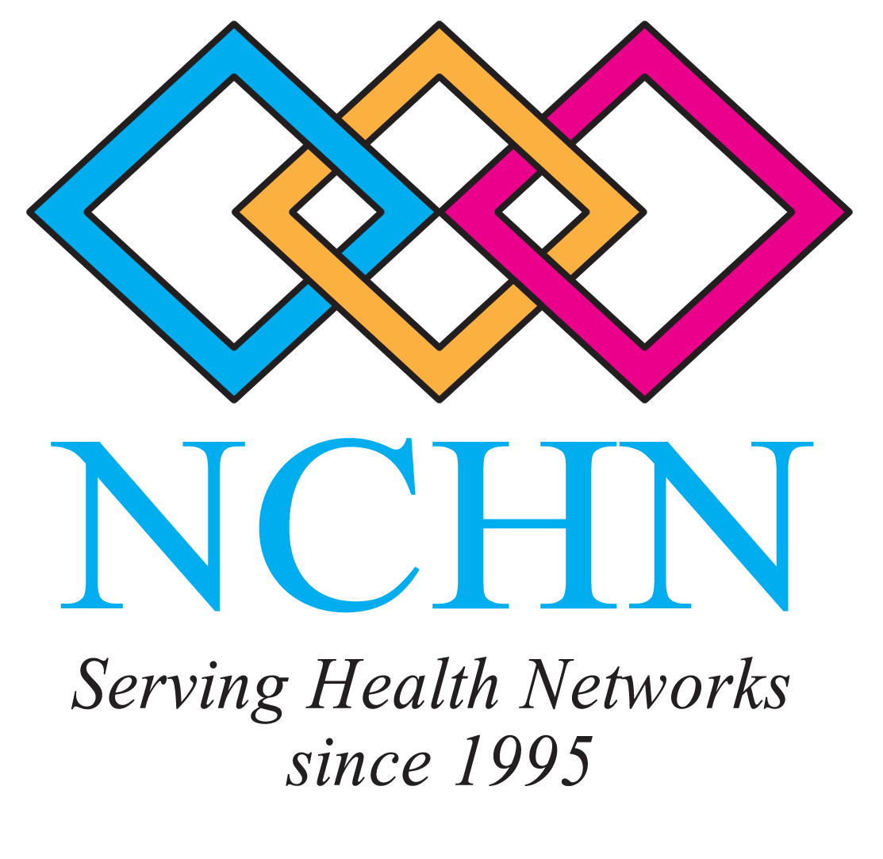 | 2012 NCHN Best Practice Models, Success Stories, and Lessons Learned Project  Email to: rdavis@nchn.org

Dear NCHN Member:

NCHN collects best practice models, success stories, and lesson learned to share with network leaders. These examples of the work that health networks are doing across the country also submitted for posting on the Rural Assistance Center Website. The example you submit could be a huge success your network enjoyed and celebrated or it could be a project you tried and it didn’t go so well – any activity, project, new program, etc., that you have implemented, expanded or tried and decided not to pursue since last year (January 2011 – June 2012) can be submitted.

So, please think about the past year and share some best practice models, success stories, and/or lessons learned! This is a great opportunity to not only distribute information widely about the great work NCHN members are doing, but it will also add to the public body of knowledge about health networks. The models will be shared through NCHN’s website, as well as on the Rural Assistance Center’s site.

If you haven’t visited NCHN’s networking section on the RAC website, here’s the link to the location that includes NCHN members’ Success Stories since 2007 - http://www.raconline.org/success/success_source_details.php?source=National%20Cooperative%20of%20Health%20Networks%20%28NCHN%29

Take a look at some of the previous Success and Lessons Learned stories posted by NCHN members and add your 2011-2012 stories today! Thanks in advance for your assistance with this project, which is designed to expand our collective networking knowledge and experience! Every NCHN member is encouraged to submit a story for 2011-2012 --- even if you have submitted a story before, please submit a new one! Info about a new project/activity/program your network may have worked on since January 2011 is sought.

The NCHN Program Development Committee has assumed management of this NCHN project and the committee members challenge you to submit your story today – all success stories received by August 1, 2012 will be included in a drawing for a $15.00 gift card.

If you have questions about this project, please contact Rebecca Davis at rdavis@nchn.org or by calling 970-712-0732.

Thank you for your participation in this project!

2012 Program Development Committee Members
2012 NCHN Best Practice Models Submission Form

NAME OF PROGRAM/SERVICE/PRODUCT:

NAME OF NETWORK:
CONTACT PERSON’S NAME:
PHONE NUMBER AND EMAIL ADDRESS:

Brief Description - Include a description of the program, service, activity, adventure -- including an explanation of why your network pursued; number of participants and/or the percentage of the network members that uses the program and/or participates in the project.

Resources Used - Describe the resources that were used to develop the program, including time, money, consultants, etc. Also include information regarding data collection and levels of commitment from the participants.

Implementation - This is really the “how you got started” section. Participants will use the information to determine if they want to follow the same plan. Describe the process in general terms; members can contact you for specific details and/or if selected to present at the conference, specifics can be offered during the presentation.

Lessons Learned, Concerns, Barriers - One of the advantages of networking is sharing best practice models, success stories and lessons learned - both successes and failures that come from trial and error. This section gives you the opportunity to share best practices and significant challenges.

Results – Use this section to describe whether the project goals were/were not accomplished including such items as cost savings, dollars leveraged, increased use of services, improvement of health outcomes for patients in service area, etc.

Other Relevant Information – This could include the method you used to evaluate the program or event and/or any other information that is relevant to other networks in the consideration of implementing such a program.

Please complete this section: (Please check the blanks if you agree to your story being published on-line, as well as in hard copy form to be distributed at the 2012 NCHN Conference. You can type your name on the signature line.)

I give permission to publish this Best Practice, Success Story or Lesson Learned Story on the Rural Assistance Center’s website under the NCHN Success Stories Section and on the NCHN Website.

I give permission for this information to be used in future NCHN publications and/or reports, with a notation of the network name and contact person.
Signature | Date

