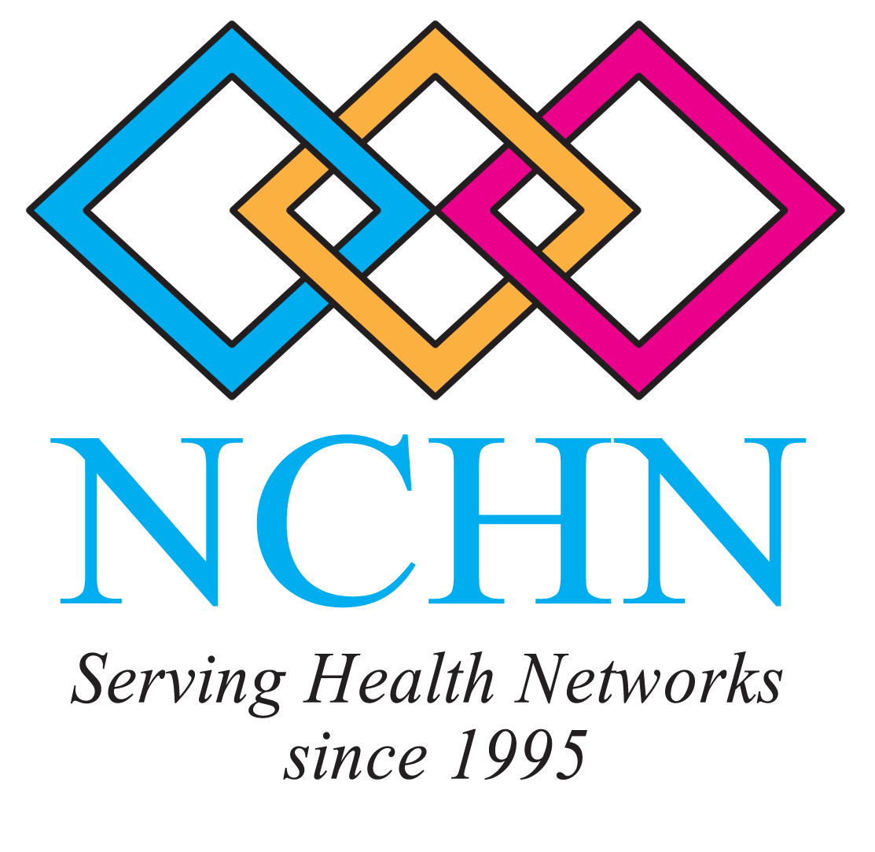 | 2012 NCHN Leadership Summit  Do What You Do Best and Link to the Rest!  September 25 - 26, 2012  The Westin Kansas City at Crown Center, Kansas City, Missouri

Tuesday, September 25, 2012

7:30 AM – 8:15 AM Opening Breakfast – Location TBA

8:15 AM – 9:10 AM Welcome & Introduction - Leadership Summit Committee

9:15 AM – 11:15 AM What the Affordable Care Act means to Healthcare Providers
Presenter - Heman A. Marshall, III, Principal, Woods Rogers, PLC, Roanoke, Virginia

In March 2010, the US Congress passed HR 3590, the Patient Protection and Affordable Care Act (PPACA or ACA – Affordable Care Act). President Obama immediately signed the bill into law. Over two years later, on June 28, 2012, the US Supreme Court upheld the constitutionality in a 5-4 ruling. Proponents of the health care legislation have called it a “historic victory” and “landmark legislation” that reforms the US health care system by reigning in health care costs, making health care affordable and protecting consumers from unfair insurance practices. Opponents have called it a “socialist” and “unconstitutional” government takeover of the health care system that will increase the cost of health care and decrease the quality. But from a practical standpoint, it is the law, so how does it really affect healthcare providers?

Mr. Marshall, a health care attorney with Woods Rogers, will discuss the overall aspects of the Affordable Care Act and the scope of the Supreme Court decision. He will also highlight the provisions upon which network leaders should be actively educating and supporting their provider members.

11:15 AM – 11:30 AM Stretch Break

11:30 AM – 12:15 PM Leadership Training for Health Network Boards Roundtable

Leadership Summit participants will share their best practice models and proven strategies for providing leadership training to their respective boards, as well, as report on board leadership training needs of their health networks.

12:15 PM – 1:15 PM Network Luncheon – Location TBA

1:15 PM – 3:45 PM Facilitation for Innovation and Collaboration in Networks
Presenter: Mary Kay Chess, Ph.D., Faculty, Bainbridge Graduate Institute in the NW and at Saybrook University, Pacific Northwest

Networks and the communities we serve face urgent and complex issues on a regular basis. It only makes sense that members and leaders of networks focus on exploring innovative and collaborative action and solutions to address these challenges. For any organization to be really successful, we need to spend some time understanding the diversity of ideas and perceptions in teams and groups. Then, we can focus on the skills needed to support sound actions and outcomes within and outside networks.
Thoughtful and engaging facilitation is one of the most important sets of skills for encouraging innovative and collaborative problem solving. Facilitation is the "process" skill we use to guide and direct key parts of our work with groups of people during meetings, planning sessions, information exchanges and trainings for our network board and community members. In this workshop with Dr. Chess, you will consider and experience:
- Diversity: Understand the diverse perspectives in the room. Please take 15 minutes to complete this quick personal assessment prior to the meeting and bring your 4 letter “formula” with you: http://www.humanmetrics.com/cgi-win/JTypes2.asp
- Teams: Understand attributes and agreements teams generate for high performance.
- Decision Making: Understand approaches to decision making based on diversity and team agreements.
- Conversations & Conflict: Understand that conflict & conversations are key contributors to innovation.

3:45- 4:00 PM Networking Break

4:00 PM – 4:30 PM Branding for Success
Presenters: Randy Jacobs, President & Kim Sojka, Account Director, TAG Healthcare Marketing, Davenport, Iowa

Is your network organization easily recognized and known to not only your membership, but within your service area? During this introductory seminar on branding, you will explore the process of weaving branding and social media marketing into your network business strategy. You will learn how you can increase your membership base by keeping your network current in today’s digital marketing climate.

4:30 PM – 4:45 PM NCHN Leadership Learning Communities Sessions

Next Steps - NCHN’s 2011 Transformer Leadership Learning Community
Heather Fuller, NCHN President

Next Steps - NCHN’s 2012 Leadership Learning Community
Mary Kay Chess, Ph.D., NCHN Leadership Learning Community Coordinator

4:45 PM – 5:00 PM Looking Forward to Effective Leadership of Health Networks

6:30 PM Meet in the lobby for a group networking dinner. Dutch treat at a local restaurant.

Wednesday, September 26, 2012

8:00 AM – 10:00 AM Special Interest Workshop for Network Leaders Seeking Foundation Funding

Partnership Strategies for Network Leaders and Foundations
Foundations are mysterious institutions to those not familiar with them. In this workshop, Steve Roling, CEO of the Health Care Foundation of Greater Kansas City and Bill Moore, Ph.D. Vice-President, Program, Policy and Evaluation of the REACH Healthcare Foundation will demystify the foundation funding mystery related to healthcare conversion foundations. They will share what their foundations are all about, describe their staffing and management procedures, and discuss current trends in their foundation giving. The focus of the workshop is on what motivates foundations to give and how you, as a network leader, can determine why they might or might not support your organization. Learn strategies and steps to determine your organization's funding needs, finding the best prospect, what makes a winning grant proposal, how to appropriately introduce your agency to a foundation, and unique proposal submission techniques.

